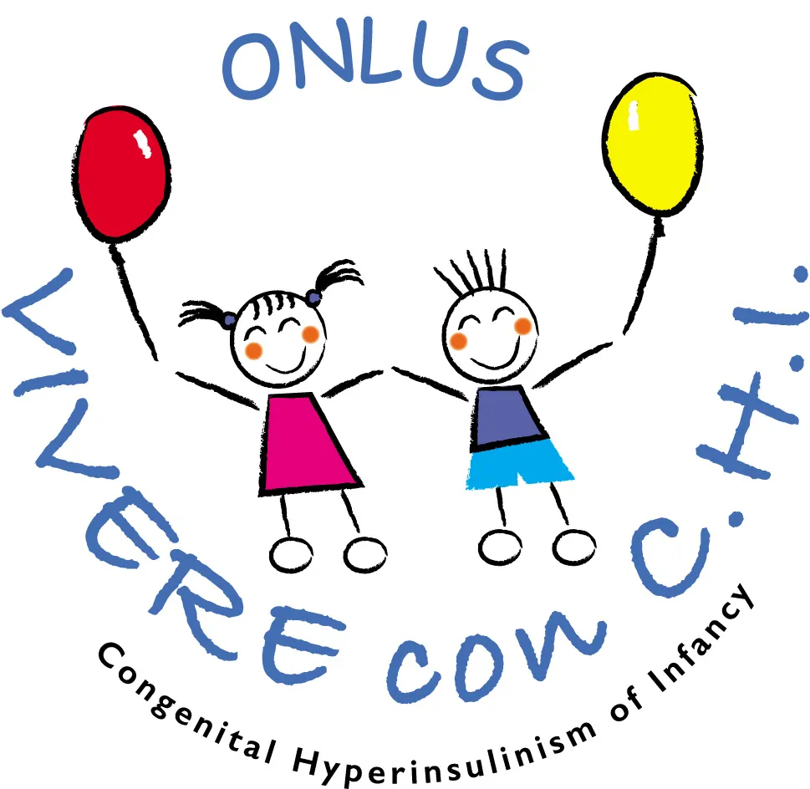
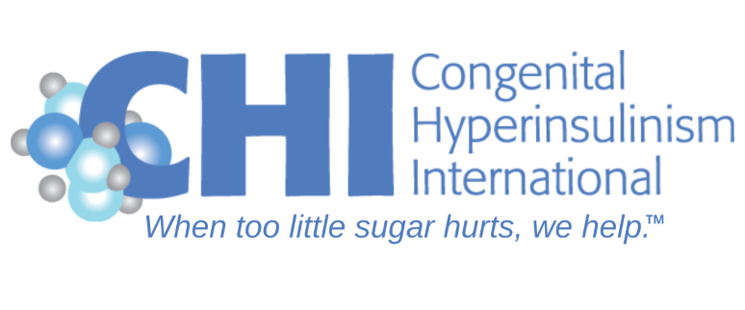

Congenital Hyperinsulinism Family Conference
September 16-18, 2022

Hotel NH Roma Villa Carpegna
Via Pio IV 6
Rome, Italy

Friday, September 16, 2022

18.00 – 21.00 Meet and Greet - Dinner Reception

Saturday, September 17, 2022

8.30 Registration and Networking

9.30 Opening Remarks
Paola Giuliani, Daniela Forcella, Julie Raskin, and Jennifer Schmitt (Conference Organizers)

9.40 "Dare to Dream: A Vision for a Future without Lows"
Presenter: Charles Stanley, MD, Children’s Hospital of Philadelphia

10.10 Congenital Hyperinsulinism (HI) in Italy
Diagnosis and Treatment
Presenter: Arianna Maiorana, MD, Bambino Gesu’ Hospital in Rome

10.40 Networking Break

11.10 Presenting the HI Global Registry and the CHI Collaborative Research Network
Patient-driven global initiatives
Presenters: Julie Raskin, Congenital Hyperinsulinism International, Ulrike Seyfarth, Kongenitaler Hyperinsulinismus e.V., Cristina Pindado, AFHICO

11.40 Learning about the Genetic Causes of HI and Understanding your Genetic Report
Presenter: Sarah Flanagan (virtual), PhD, Molecular Genetics Laboratory, University of Exeter

12.10 Glucose Monitoring in Congenital Hyperinsulinism:
      - Do HI patients benefit from using CGMs?
      - How are CGMs used in scientific studies?
Presenters: Antonia Dastamani, MD, Great Ormond Street Hospital, Indi Banerjee, MD, Royal Manchester Children’s Hospital

12.40 Management of HI After Diagnosis and Treatment Regimen has been Established:
      - When is a Change in Management needed to Reduce Hypoglycemia?
      - When can Medical Treatment/Carbohydrate Therapy be Stopped?
      - When is a Change in Management Needed to Reduce Hyperglycemia?
Presenter: Diva De León-Crutchlow, MD, Children’s Hospital of Philadelphia

13.10 Lunch

14.10 Feeding and Eating:
- Should diet play a role in managing congenital hyperinsulinism by HI type? If so, how?
- What are strategies to help with feeding issues?
Presenters: Thomas Meissner, MD, University Children’s Hospital Düsseldorf, Sara Osimani, MD, San Raffaele Scientific Institute

14:40 Biotechs on the Move: Treatments in Development (part 1)
- Rezolute: Davelyn Hood, MD and Jeffrey Breit, PhD
- Crinetics: Christine Ferrara-Cook, MD, PhD

15.10 Networking Break

15.40 Biotechs on the Move: Treatments in Development (part 2)

- Eiger BioPharmaceuticals: Colleen Craig, MD
- Hanmi: Hyungjin Cho, MD
- Zealand Pharma: Jelena Ivkovic, MD and Chandra Slusser

16.20 Hyperinsulinism 101: Ask the Experts
Chair and Moderator of Session: Giuseppe Chiumello, MD, Faculty of Medicine, University of Milan
Sample Question Topics:
Challenges to Managing HI in infants and Toddlers
HI and Growth and Development
Feeding difficulties
Nutrition
When Hypoglycemia is Still an Issue
Transition from Pediatric to Adult Care
More on Genetics
Dealing with Highs and Lows
Issues with Access to Care
Rare Disease Advocacy
Devices
Sick Days
HI Global Registry
Participating in Research Studies

Speakers:
Indi Banerjee, MD, Royal Manchester Children’s Hospital
Oliver Blankenstein, MD, Charite Hospital
Laura Byers, Great Ormond Street Hospital
Henrik Christesen, MD, Hans Christian Anderson Children’s Hospital
Diva De León-Crutchlow, MD, Children’s Hospital of Philadelphia
Hüseyin Demirbilek, MD, Hacettepe University
Maria Salomon Estebanez, MD, Royal Manchester Children’s Hospital
Sebastian Kummer, MD, University Children’s Hospital Düsseldorf
Katherine Lord, MD, Children’s Hospital of Philadelphia
Arianna Maiorana, MD, Bambino Gesu’ Hospital in Rome
Thomas Meissner, MD, University Children’s Hospital Düsseldorf
Roberta Pajno, MD, Milan Ospedale San Raffaele Scientific Institute
Charles Stanley, MD, Children’s Hospital of Philadelphia
Chris Worth, MD, Royal Manchester Children’s Hospital
And Biotech Speakers

16.50 Congenital Hyperinsulinism In Turkey
Presenter: Hüseyin Demirbilek, MD, Hacettepe University

17.05 End of daytime programming

18.00 – 21.00 Conference Reception and dinner with
Keynote Speaker: A Parent on a Mission: Meet Claudine van der Sande, CEO of Xinvento

Sunday, September 18, 2022

9.00 The Role of Advocacy in Advancing Compassionate Care for Children with HI
Presenter: Sir Albert Aynsley-Green, MD
With guided discussion

9.45 Living with HI – Our stories
Vivere Con CHI presentation followed by presentations from Families in Italy
Presented and moderated by Daniela Forcella and Paola Guiliani
Other presenters: Patient, caregivers, and advocates share their experiences and work

10.45 Networking Break

11.00 Coping with the Stress of Parenting a Child with Congenital Hyperinsulinism
Presenter: Julie Raskin

11:15 Small Group Discussions on Special Topics
- Newly Diagnosed – Moderated by Arianna Maiorana – no translator
- Families of Teens with Hyperinsulinism/Young Adults – Moderated by Charles Stanley, MD and Paul Seyfarth
- Hyperinsulinism at School- Moderated by TBD
- Open Discussion Moderated - Ulrike Seyfarth and Oliver Blankenstein, MD

12.00 Optional Networking Lunch

